During pandemic, the following Analysis revealed the performance of crypto currency from 2020 to 2021 and the following are the graphs of all four asset allocation methods to identify in which crypto currency has performed best. 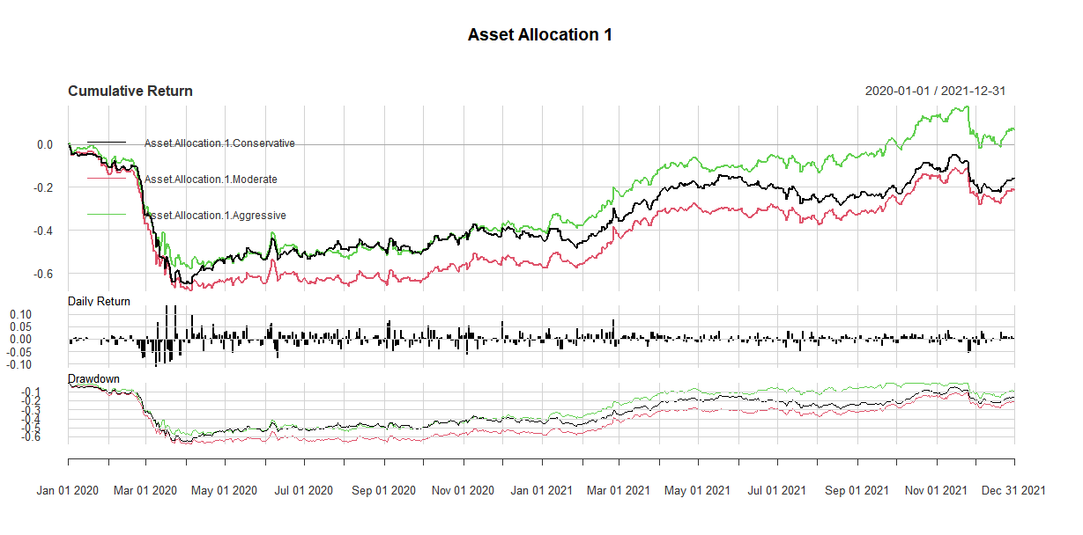

Until the mid of 2020, the market was not performing well because of the pandemic that is why we have a seen a drop of performance of Gold as well as NASDAQ index. But after that, aggressive strategy starting yielding returns because NASDAQ started performing well.

|  |  |  |  |  |  |
| --- | --- | --- | --- | --- | --- |
|  | Sharp | Sortino | VaR | Skewness | Kurtosis |
| Conservative | -0.162721 | 0.0009842183 | -0.03377918 | 0.02168996 | 6.771665 |
| Moderate | -0.1906058 | 0.001002941 | -0.0410654 | -0.1927092 | 6.792334 |
| Aggressive | 0.06156486 | 0.02105181 | -0.03528637 | -0.4612225 | 9.081109 |

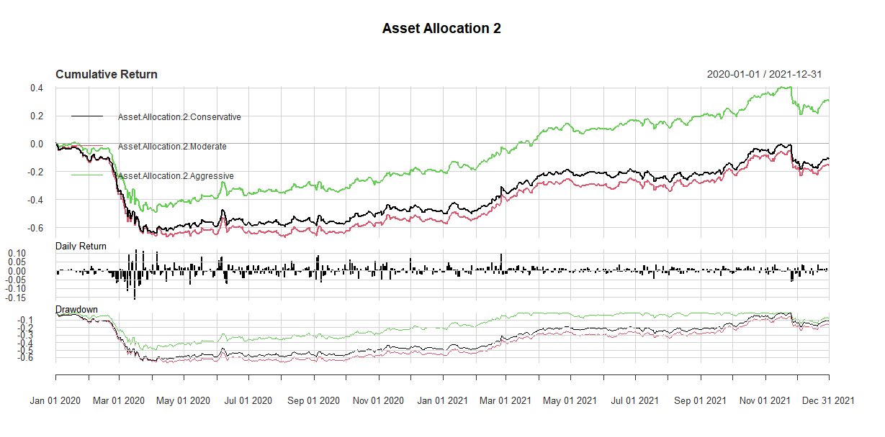

In this again the aggressive strategy was performing well because the funds allocated to this have minimum gold in them and that is why, although the return was low but NASQAD and Treasury after 2021 start yielding results.

|  |  |  |  |  |  |
| --- | --- | --- | --- | --- | --- |
|  | Sharp | Sortino | VaR | Skewness | Kurtosis |
| Conservative | -0.1038518 | 0.007480308 | -0.03755524 | -0.2652647 | 7.295507 |
| Moderate | -0.134736 | 0.006722163 | -0.04220624 | -0.2812899 | 7.441247 |
| Aggressive | 0.3208453 | 0.03974285 | -0.02927923 | -0.7023152 | 11.87339 |

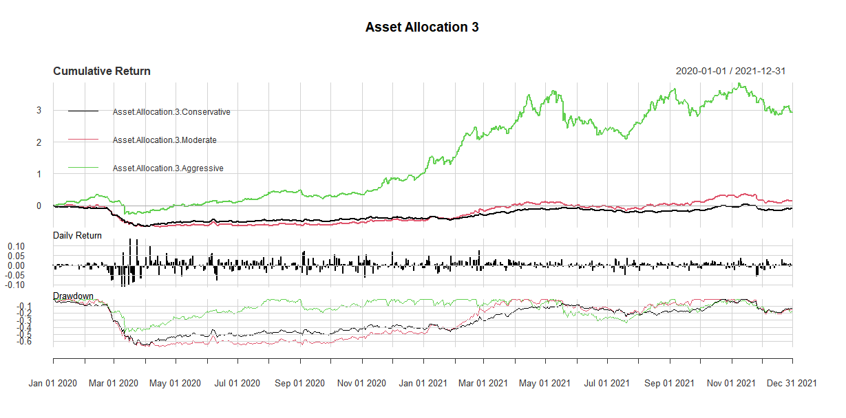

In this strategy, maximum amount of returns have been assigned to aggressive strategy and that is why the return from this strategy has been so much greater than anyone in the time frame of two years. Because of the hypothesis, there is a negative relation between crypto currency and stock market and that is what we are witnessing.

|  |  |  |  |  |  |
| --- | --- | --- | --- | --- | --- |
|  | Sharp | Sortino | VaR | Skewness | Kurtosis |
| Conservative | -0.09801339 | 0.007016494 | -0.03416116 | -0.0303167 | 6.704376 |
| Moderate | 0.1061656 | 0.0285784 | -0.04560421 | -0.5109544 | 6.365213 |
| Aggressive | 1.415377 | 0.1120175 | -0.04553358 | -1.939524 | 16.91972 |

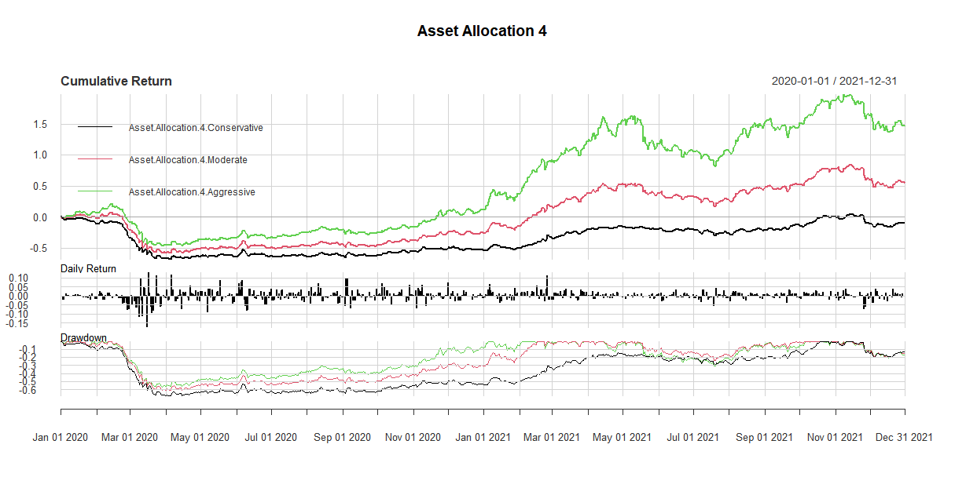

In this again, aggressive is returning the maximum results and the ratios are also calculated as:

|  |  |  |  |  |  |
| --- | --- | --- | --- | --- | --- |
|  | Sharp | Sortino | VaR | Skewness | Kurtosis |
| Conservative | -0.08358928 | 0.01103633 | -0.04175109 | -0.2678624 | 6.473187 |
| Moderate | 0.421978 | 0.05060902 | -0.0410232 | -0.9069591 | 8.369728 |
| Aggressive | 0.8954591 | 0.08235681 | -0.04383558 | -1.580579 | 13.27949 |

# Conclusion

During pandemic, crypto has been the most valuable asset to invest in.